产品概要

輸出額定力矩
T_{2N} :12 Nm - 3,200 Nm
減速比:
單節 :1 / 1.5 / 2 / 3 / 4 / 5
雙節 :7 / 10 / 15 / 20 / 25 / 35 / 50
三節 :75 / 100 / 125 / 150 / 200 / 250 / 350 / 500
低背隙
單節 :≦6 arcmin
雙節 :≦8 arcmin
三節 :≦10 arcmin
高效率
單節 : ≧ 98%
雙節 : ≧ 94%
三節 : ≧ 94%
容易安裝
低噪音
結構緊湊
材質: 染黑鑄鐵

产品规格
減速機性能資料
規格 |  | 節數 | 減速比¹ | ATB065FC | ATB075FC | ATB090FC | ATB110FC | ATB140FC | ATB170FC | ATB210FC | ATB240FC | ATB280FC
額定輸出力矩 T_{2N} | Nm | 1 | 1 | 25 | 45 | 78 | 150 | 360 | 585 | 1,300 | 2,150 | 3,200
額定輸出力矩 T_{2N} | Nm | 1 | 1.5 | 25 | 45 | 78 | 150 | 360 | 585 | 1,300 | 2,150 | 3,200
額定輸出力矩 T_{2N} | Nm | 1 | 2 | 24 | 42 | 68 | 150 | 330 | 544 | 1,220 | 2,010 | 3,050
額定輸出力矩 T_{2N} | Nm | 1 | 3 | 18 | 33 | 54 | 120 | 270 | 450 | 1,020 | 1,650 | 2,850
額定輸出力矩 T_{2N} | Nm | 1 | 4 | 13 | 28 | 48 | 100 | 224 | 376 | 860 | 1,410 | 2,300
額定輸出力矩 T_{2N} | Nm | 1 | 5 | 12 | 25 | 40 | 85 | 196 | 320 | 740 | 1,210 | 2,000
額定輸出力矩 T_{2N} | Nm | 2 | 7 | 12 | 12 | 33 | 91 | 91 | 91 | 195 | 358 | 358
額定輸出力矩 T_{2N} | Nm | 2 | 10 | 24 | 28 | 68 | 150 | 208 | 208 | 430 | 846 | 846
額定輸出力矩 T_{2N} | Nm | 2 | 15 | 18 | 33 | 54 | 120 | 270 | 312 | 645 | 1,269 | 1,269
額定輸出力矩 T_{2N} | Nm | 2 | 20 | 13 | 28 | 48 | 100 | 224 | 376 | 860 | 1,410 | 1,692
額定輸出力矩 T_{2N} | Nm | 2 | 25 | 12 | 25 | 40 | 85 | 196 | 320 | 740 | 1,210 | 2,000
額定輸出力矩 T_{2N} | Nm | 2 | 35 | 12 | 25 | 40 | 85 | 196 | 320 | 740 | 1,210 | 1,790
額定輸出力矩 T_{2N} | Nm | 2 | 50 | 12 | 25 | 40 | 85 | 196 | 320 | 740 | 1,210 | 1,465
額定輸出力矩 T_{2N} | Nm | 3 | 75 | - | - | - | 120 | 210 | 312 | 585 | 1,269 | 1,269
額定輸出力矩 T_{2N} | Nm | 3 | 100 | - | - | - | 100 | 224 | 376 | 780 | 1,410 | 1,692
額定輸出力矩 T_{2N} | Nm | 3 | 125 | - | - | - | 85 | 196 | 320 | 740 | 1,210 | 2,000
額定輸出力矩 T_{2N} | Nm | 3 | 150 | - | - | - | 120 | 135 | 312 | 390 | 975 | 975
額定輸出力矩 T_{2N} | Nm | 3 | 200 | - | - | - | 100 | 180 | 376 | 520 | 1,300 | 1,300
額定輸出力矩 T_{2N} | Nm | 3 | 250 | - | - | - | 85 | 196 | 320 | 650 | 1,210 | 1,625
額定輸出力矩 T_{2N} | Nm | 3 | 350 | - | - | - | 85 | 196 | 320 | 740 | 1,210 | 1,790
額定輸出力矩 T_{2N} | Nm | 3 | 500 | - | - | - | 85 | 196 | 320 | 740 | 1,210 | 1,465
最大加速力矩 T_{2B} | Nm | 1,2,3 | 1~500 | 1.5倍額定輸出力矩
最大加速輸入轉速 n_{1B} | rpm | 1 | 1~5 | 7,500 | 6,500 | 5,500 | 4,500 | 3,500 | 3,000 | 2,200 | 2,000 | 1,700
最大加速輸入轉速 n_{1B} | rpm | 2 | 7~50 | 8,000 | 8,000 | 6,000 | 6,000 | 6,000 | 6,000 | 4,800 | 3,600 | 3,600
最大加速輸入轉速 n_{1B} | rpm | 3 | 75~500 | - | - | - | 8,000 | 8,000 | 6,000 | 6,000 | 6,000 | 6,000
標準背隙* | arcmin | 1 | 1~5 | ≤ 6 | ≤ 6 | ≤ 6 | ≤ 6 | ≤ 6 | ≤ 6 | ≤ 6 | ≤ 6 | ≤ 6
標準背隙* | arcmin | 2 | 7~50 | ≤ 8 | ≤ 8 | ≤ 8 | ≤ 8 | ≤ 8 | ≤ 8 | ≤ 8 | ≤ 8 | ≤ 8
標準背隙* | arcmin | 3 | 75~500 | - | - | - | ≤ 10 | ≤ 10 | ≤ 10 | ≤ 10 | ≤ 10 | ≤ 10
最大徑向力 F_{2rB}2  輸出 d2 | N | 1,2,3 | 1~500 | 900 | 1,100 | 1,700 | 2,700 | 4,800 | 6,600 | 11,500 | 16,000 | 18,000
最大軸向力 F_{2aB}2  輸出 d2 | N | 1,2,3 | 1~500 | 450 | 550 | 850 | 1,350 | 2,400 | 3,300 | 5,750 | 8,500 | 9,000
使用壽命 | hr | 1 | 1~500 | 20,000*
效率 | % | 1 | 1~5 | ≧ 98 %
 | % | 2,3 | 7~500 | ≧ 94 %
重量 | kg | 1 | 1~5 | 2.9 | 4.4 | 7.2 | 11.8 | 20.4 | 35.0 | 66.5 | 96.0 | 151.7
重量 | kg | 2 | 7~50 | 3.3 | 4.9 | 8.2 | 14.1 | 24.1 | 37.4 | 71.2 | 107.2 | 164.4
重量 | kg | 3 | 75~500 | - | - | - | 13.7 | 23.5 | 37.5 | 70.5 | 105.0 | 162.2
使用溫度 | ºC | 1,2,3 | 1~500 | -10ºC~90ºC
潤滑 |  | - | - | Synthetic Iubrication, ISO VG 150
噪音值  (n₁=1500 rpm,無負載) | dB(A) | 1,2,3 | 1~500 | ≤71 | ≤72 | ≤76 | ≤77 | ≤78 | ≤79 | ≤81 | ≤83 | ≤84

1.減速比 ( i =N_{in}/N_{out} ) | 3.轉速在100rpm時，作用於輸入軸中心位置。
*連續運轉，使用壽命為10,000 hrs.
*背隙值為在2%額定力矩 T2N的扭力下所測得
*AT系列之低摩擦型號, 其輸入/輸出端禁止朝下安裝, 以防止潤滑油洩漏.

減速機轉動慣量
規格 | 節數 | 減速比¹ | ATB065FC | ATB075FC | ATB090FC | ATB110FC | ATB140FC | ATB170FC | ATB210FC | ATB240FC | ATB280FC
轉動慣量J₁（kg·cm² ） | 1 | 1 | 0.51 | 1.30 | 3.14 | 7.62 | 23.54 | 59.09 | 195.96 | 365.38 | 787.63
轉動慣量J₁（kg·cm² ） | 1 | 1.5 | 0.46 | 1.15 | 2.80 | 6.65 | 19.34 | 49.38 | 156.02 | 279.62 | 584.28
轉動慣量J₁（kg·cm² ） | 1 | 2 | 0.44 | 1.10 | 2.68 | 6.23 | 17.72 | 45.44 | 140.80 | 245.78 | 500.26
轉動慣量J₁（kg·cm² ） | 1 | 3 | 0.43 | 1.09 | 2.64 | 6.08 | 17.16 | 44.11 | 135.51 | 233.75 | 471.56
轉動慣量J₁（kg·cm² ） | 1 | 4 | 0.43 | 1.08 | 2.63 | 6.05 | 17.03 | 43.79 | 134.14 | 230.77 | 464.76
轉動慣量J₁（kg·cm² ） | 1 | 5 | 0.43 | 1.08 | 2.63 | 6.04 | 16.99 | 43.69 | 133.71 | 229.71 | 462.08
轉動慣量J₁（kg·cm² ） | 2 | 7 | 0.15 | 0.15 | 0.50 | 2.79 | 2.79 | 2.79 | 9.91 | 29.26 | 29.26
轉動慣量J₁（kg·cm² ） | 2 | 10 | 0.15 | 0.15 | 0.50 | 2.80 | 2.80 | 2.80 | 9.96 | 29.43 | 29.43
轉動慣量J₁（kg·cm² ） | 2 | 15 | 0.15 | 0.15 | 0.50 | 2.80 | 2.80 | 2.80 | 9.96 | 29.43 | 29.43
轉動慣量J₁（kg·cm² ） | 2 | 20 | 0.15 | 0.15 | 0.50 | 2.80 | 2.80 | 2.80 | 9.96 | 29.43 | 29.43
轉動慣量J₁（kg·cm² ） | 2 | 25 | 0.15 | 0.15 | 0.50 | 2.80 | 2.80 | 2.80 | 9.96 | 29.43 | 29.43
轉動慣量J₁（kg·cm² ） | 2 | 35 | 0.15 | 0.15 | 0.50 | 2.79 | 2.79 | 2.79 | 9.91 | 29.26 | 29.26
轉動慣量J₁（kg·cm² ） | 2 | 50 | 0.15 | 0.15 | 0.50 | 2.79 | 2.79 | 2.79 | 9.89 | 29.20 | 29.20
轉動慣量J₁（kg·cm² ） | 3 | 75 | - | - | - | 2.80 | 2.80 | 2.80 | 9.96 | 29.43 | 29.43
轉動慣量J₁（kg·cm² ） | 3 | 100 | - | - | - | 2.80 | 2.80 | 2.80 | 9.96 | 29.43 | 29.43
轉動慣量J₁（kg·cm² ） | 3 | 125 | - | - | - | 2.80 | 2.80 | 2.80 | 9.96 | 29.43 | 29.43
轉動慣量J₁（kg·cm² ） | 3 | 150 | - | - | - | 2.79 | 2.79 | 2.79 | 9.89 | 29.20 | 29.20
轉動慣量J₁（kg·cm² ） | 3 | 200 | - | - | - | 2.79 | 2.79 | 2.79 | 9.89 | 29.20 | 29.20
轉動慣量J₁（kg·cm² ） | 3 | 250 | - | - | - | 2.79 | 2.79 | 2.79 | 9.89 | 29.20 | 29.20
轉動慣量J₁（kg·cm² ） | 3 | 350 | - | - | - | 2.79 | 2.79 | 2.79 | 9.89 | 29.20 | 29.20
轉動慣量J₁（kg·cm² ） | 3 | 500 | - | - | - | 2.79 | 2.79 | 2.79 | 9.89 | 29.20 | 29.20

产品尺寸

單節( 減速比 i = 1 ~ 5 )
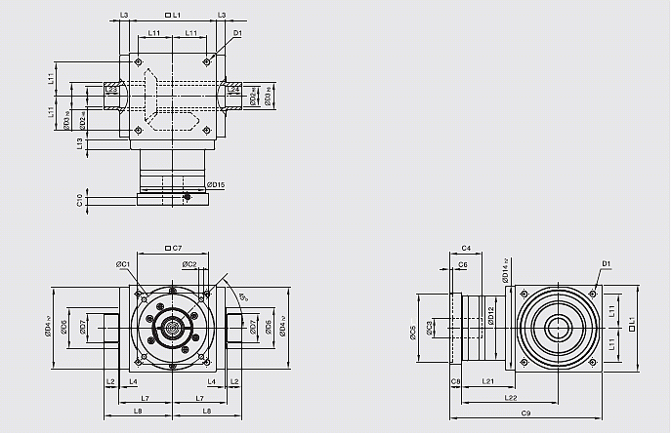

 | ATB065FC | ATB075FC | ATB090FC | ATB110FC | ATB140FC | ATB170FC | ATB210FC | ATB240FC | ATB280FC
D1 | M4 | M6 | M6 | M8 | M10 | M12 | M16 | M16 | M16
D2 _{H6} | 13 | 14 | 18 | 22 | 32 | 40 | 50 | 55 | 60
D3 _{h8} | 16 | 16 | 22 | 25 | 44 | 50 | 62 | 68 | 75
D4 _{h7} | 63 | 73 | 88 | 108 | 135 | 165 | 205 | 235 | 275
D12 | 62 | 72 | 86 | 106 | 104 | 128 | 160 | 180 | 200
D14 _{h7} | 63 | 73 | 88 | 108 | 135 | 165 | 205 | 235 | 275
D15 | 62.9 | 72.9 | 87 | 107 | 105 | 130 | 158 | 178 | 198
D17 | 26 | 26 | 36 | 38 | 61 | 70 | 86 | 86 | 100
D18 | 41 | 41 | 50 | 50 | 80 | 90 | 110 | 115 | 138
L1 | 65 | 75 | 90 | 110 | 140 | 170 | 210 | 240 | 280
L2 | 14 | 14 | 18 | 18 | 24 | 26 | 29 | 29 | 30.5
L3 | 13 | 14.5 | 15 | 15 | 15 | 15 | 20 | 25 | 25
L4 | 2 | 2 | 2 | 2 | 2 | 2 | 2 | 2 | 2
L7 | 47.5 | 54 | 62 | 72 | 87 | 102 | 127 | 147 | 167
L8 | 66 | 72.5 | 85 | 95 | 116.5 | 113.5 | 161.5 | 181.5 | 205
L11 | 27 | 30 | 36 | 44 | 55 | 67 | 85 | 95 | 110
L13 | 13 | 15 | 15 | 15 | 15 | 15 | 20 | 25 | 25
L21 | 49 | 60.5 | 63 | 69.5 | 85.5 | 95 | 130 | 144.5 | 135
L22 | 81.5 | 98 | 108 | 124.5 | 155.5 | 180 | 235 | 264.5 | 275
L23 | 15 | 15 | 20 | 20 | 26 | 28 | 31 | 31 | 32.5
L24 | 15 | 15 | 20 | 20 | 26 | 28 | 31 | 31 | 32.5
L25 | 15 | 15 | 19.5 | 19.5 | 25.5 | 27.5 | 30.5 | 30.5 | 32.5
L26 | 18.5 | 18.5 | 23 | 23 | 29.5 | 31.5 | 34.5 | 34.5 | 38
C1 ¹² | 46 | 70 | 100 | 100 | 130 | 165 | 215 | 215 | 235
C2 ¹² | M4 | M5 | M6 | M6 | M8 | M10 | M12 | M12 | M12
C3 ¹² | ≤11 / ≤12 | ≤14 / ≤15.875 / ≤16 | ≤19 | ≤24 | ≤32 | ≤38 | ≤42 | ≤48 | ≤55
C4 ¹² | 30 | 34 | 40 | 40 | 50 | 60 | 85 | 85 | 116
C5 ¹²_{G6} | 30 | 50 | 80 | 80 | 110 | 130 | 180 | 180 | 200
C6 ¹² | 3.5 | 8 | 4 | 4 | 5 | 6 | 6 | 6 | 6
C7 ¹² | 42 | 60 | 90 | 90 | 115 | 142 | 190 | 190 | 220
C8 ¹² | 19.5 | 19 | 17 | 17 | 19.5 | 22.5 | 29 | 29 | 63
C9 ¹² | 133.5 | 154.5 | 170 | 196.5 | 245 | 287.5 | 369 | 413.5 | 478
C10 ¹² | 13.25 | 13.5 | 10.75 | 10.75 | 13 | 15 | 20.75 | 20.75 | 53.5

12. C1~C10 是公制標準馬達連接板之尺寸，請至 " 減速機選用 " 找出正確之尺寸。
*ATB065-FCM1 offers C3 <= 12 option.
*ATB075-FCM1 offers C3 <= 16 option.
*ATB075-FCM2 offers C3 <= 15.875 option.

2-stage( 減速比 i = 7 ~ 50 )
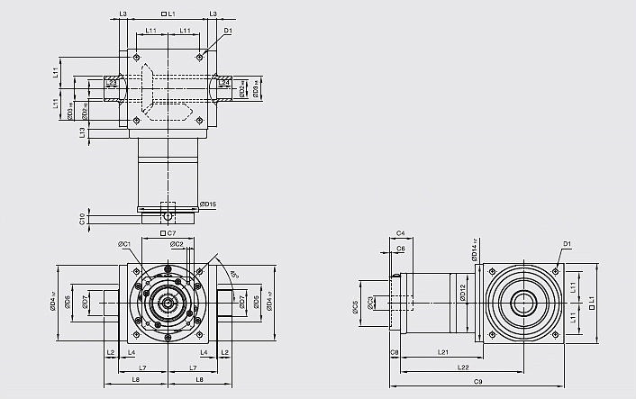

 | ATB065FC | ATB075FC | ATB090FC | ATB110FC | ATB140FC | ATB170FC | ATB210FC | ATB240FC | ATB280FC
D1 | M4 | M6 | M6 | M8 | M10 | M12 | M16 | M16 | M16
D2 _{H6} | 13 | 14 | 18 | 22 | 32 | 40 | 50 | 55 | 60
D3 _{h8} | 16 | 16 | 22 | 25 | 44 | 50 | 62 | 68 | 75
D4 _{h7} | 63 | 73 | 88 | 108 | 135 | 165 | 205 | 235 | 275
D12 | 62 | 72 | 86 | 106 | 104 | 128 | 160 | 180 | 200
D14 _{h7} | 63 | 73 | 88 | 108 | 135 | 165 | 205 | 235 | 275
D15 | 62.9 | 72.9 | 87 | 107 | 106 | 127 | 158 | 178 | 198
D17 | 26 | 26 | 36 | 38 | 61 | 70 | 86 | 86 | 100
D18 | 41 | 41 | 50 | 50 | 80 | 90 | 110 | 115 | 138
L1 | 65 | 75 | 90 | 110 | 140 | 170 | 210 | 240 | 280
L2 | 14 | 14 | 18 | 18 | 24 | 26 | 29 | 29 | 30.5
L3 | 13 | 14.5 | 15 | 15 | 15 | 15 | 20 | 25 | 25
L4 | 2 | 2 | 2 | 2 | 2 | 2 | 2 | 2 | 2
L7 | 47.5 | 54 | 62 | 72 | 87 | 102 | 127 | 147 | 167
L8 | 66 | 72.5 | 85 | 95 | 116.5 | 133.5 | 161.5 | 181.5 | 205
L11 | 27 | 30 | 36 | 44 | 55 | 67 | 85 | 95 | 110
L13 | 13 | 15 | 15 | 15 | 15 | 15 | 20 | 25 | 25
L21 | 75 | 84.5 | 99 | 122 | 144.5 | 157.5 | 206.5 | 239 | 248
L22 | 107.5 | 122 | 144 | 177 | 214.5 | 242.5 | 311.5 | 359 | 388
L23 | 15 | 15 | 20 | 20 | 26 | 28 | 31 | 31 | 32.5
L24 | 15 | 15 | 20 | 20 | 26 | 28 | 31 | 31 | 32.5
L25 | 15 | 15 | 19.5 | 19.5 | 25.5 | 27.5 | 30.5 | 30.5 | 32.5
L26 | 18.5 | 18.5 | 23 | 23 | 29.5 | 31.5 | 34.5 | 34.5 | 38
C1 ¹³ | 46 | 46 | 70 | 100 | 100 | 100 | 130 | 165 | 165
C2 ¹³ | M4 | M4 | M5 | M6 | M6 | M6 | M8 | M10 | M10
C3 ¹³ | ≤12 | ≤12 | ≤16 | ≤24 | ≤24 | ≤24 | ≤32 | ≤38 | ≤38
C4 ¹³ | 30 | 30 | 34 | 40 | 40 | 40 | 50 | 60 | 60
C5 ¹³ | 30 | 30 | 50 | 80 | 80 | 80 | 110 | 130 | 130
C6 ¹³ | 3.5 | 3.5 | 8 | 4 | 4 | 4 | 5 | 6 | 6
C7 ¹³ | 42 | 42 | 60 | 92 | 92 | 92 | 115 | 142 | 142
C8 ¹³ | 21.5 | 21.5 | 21.5 | 20 | 20 | 20 | 24 | 31 | 31
C9 ¹³ | 161.5 | 181 | 210.5 | 252 | 304.5 | 347.5 | 440.5 | 510 | 559
C10 ¹³ | 14.5 | 14.5 | 15.5 | 13 | 13 | 13 | 16 | 21 | 21

13. C1~C10 是公制標準馬達連接板之尺寸，請至 " 減速機選用 " 找出正確之尺寸。

3-stage( 減速比 i = 75 ~ 500 )
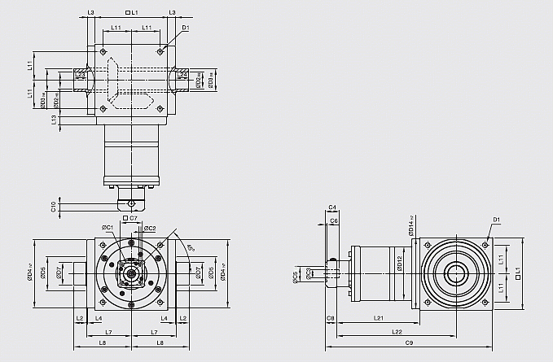

 | ATB110FC | ATB140FC | ATB170FC | ATB210FC | ATB240FC | ATB280FC
D1 | M8 | M10 | M12 | M16 | M16 | M16
D2 _{H6} | 22 | 32 | 40 | 50 | 55 | 60
D3 _{h8} | 25 | 44 | 50 | 62 | 68 | 75
D4 _{h7} | 108 | 135 | 165 | 205 | 235 | 275
D12 | 106 | 104 | 128 | 160 | 180 | 200
D14 _{h7} | 108 | 135 | 165 | 205 | 235 | 275
D15 | 107 | 106 | 127 | 158 | 178 | 198
D17 | 38 | 61 | 70 | 86 | 86 | 100
D18 | 50 | 80 | 90 | 110 | 115 | 138
L1 | 110 | 140 | 170 | 210 | 240 | 280
L2 | 18 | 24 | 26 | 29 | 29 | 30.5
L3 | 15 | 15 | 15 | 20 | 25 | 25
L4 | 2 | 2 | 2 | 2 | 2 | 2
L7 | 72 | 87 | 102 | 127 | 147 | 167
L8 | 95 | 116.5 | 133.5 | 161.5 | 181.5 | 205
L11 | 44 | 55 | 67 | 85 | 95 | 110
L13 | 15 | 15 | 15 | 20 | 25 | 25
L21 | 136.5 | 159.5 | 183.5 | 226 | 269 | 278
L22 | 191.5 | 229.5 | 268.5 | 331 | 389 | 418
L23 | 20 | 26 | 28 | 31 | 31 | 32.5
L24 | 20 | 26 | 28 | 31 | 31 | 32.5
L25 | 19.5 | 25.5 | 27.5 | 30.5 | 30.5 | 32.5
L26 | 23 | 29.5 | 31.5 | 34.5 | 34.5 | 38
C1 ¹⁴ | 46 | 46 | 70 | 70 | 100 | 100
C2 ¹⁴ | M4 | M4 | M5 | M5 | M6 | M6
C3 ¹⁴ | ≤12 | ≤12 | ≤16 | ≤16 | ≤24 | ≤24
C4 ¹⁴ | 30 | 30 | 34 | 34 | 40 | 40
C5 ¹⁴ | 30 | 30 | 50 | 50 | 80 | 80
C6 ¹⁴ | 3.5 | 3.5 | 8 | 8 | 4 | 4
C7 ¹⁴ | 42 | 42 | 60 | 60 | 92 | 92
C8 ¹⁴ | 21.5 | 21.5 | 21.5 | 21.5 | 20 | 20
C9 ¹⁴ | 268 | 321 | 375 | 457.5 | 529 | 578
C10 ¹⁴ | 14.5 | 14.5 | 15.5 | 15.5 | 13 | 13

14. C1~C10 是公制標準馬達連接板之尺寸，請至 " 減速機選用 " 找出正確之尺寸。

